# Your Social Prescribing Link Workers

**Eunice Barnes and Nikki Davies** work alongside GP's and other staff in your Doctors Surgery.

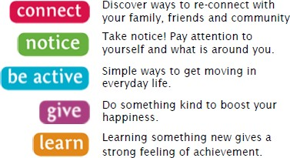

# Which practices we work with?

**Willowbank Surgery,**

Meir Primary Care Centre, Weston Road, Stoke- on-Trent, ST3 6AB

0300 123 5002

**Dr P D Miles and Dr R Valasapalli,**

Meir Primary Care Centre, Weston Road, Stoke- on-Trent, ST3 6AB

01782 315654

**Meir Medical Practice**

Meir Primary Care Centre, Weston Road, Stoke- on-Trent, ST3 6AB

01782 315654

**Adderley Green Surgery,**

Longton Health Centre, Drayton Road, Stoke- on-Trent, ST3 1EQ

01782 311266

**Meir Park and Weston Coyney Medical Practice,**

Lysander Road, Stoke-on-Trent, ST7TW

01782 388204

**Trinity Medical Centre,**

01782 395101

Social Prescribing

Connecting you with your community



# What is Social Prescribing*?*

At its most basic, a ‘*social prescription’* offers the kind of help that doesn’t come in a tube or a bottle. The idea behind social prescribing is to help you to have more control over your own health and find ways to improve how you feel in a way that suits you.

*Studies show that patients with social prescriptions get better and feel better faster than those treated with medicine alone. And because it works, it’s happening more and more.*

# Your Social Prescribing Link Worker

# Will listen, explore *'what matters to you'*, support and work with you to create a personal plan highlighting your needs.

Your Link Worker can provide a short-term service to support, activities, information and signposting within the local community by linking in with voluntary community sector organisations and other agencies allowing you to enjoy healthy lifestyle changes.

# Social Prescribing helps people

# To change their lifestyle by linking people into community support and resources (including online) by signposting or referring. This can include:

-

* Lifestyle support to help improve your health. i.e., weight loss/ stop smoking/more exercise
* Services and agencies to help stay as independent as possible.
* Support groups to help you better manage a physical or mental health condition
* Support to volunteer, training find work
* Support to services to help claim benefits, budget, or deal with debts
* Support with housing issues
* Support for persons experiencing loneliness / loss
* Community groups to gain new networks and develop friendships

*Social Prescribing can help us with things that can’t be fixed by doctors and medicine alone.*

# To access social prescribing

It’s simple, speak to your GP or Health Care Professional at your GP surgery and ask to be referred to your Social Prescribing Link Worker.

You will be contacted to arrange a convenient time to talk to you in more detail about your needs and the support that can be offered.

For more details please contact:

Mark Lawton

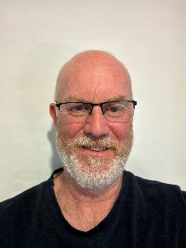

Mark.lawton@stoke.nhs.uk